Ship4

ANDREWS CENTRE

## ENDEAVOUR MINISTRIES

2-6 Hanna Drive, Endeavour Hills, 3802

Telephone 03 9700 4944

Fax 03 9700 0822

ABN 70 891 996 288

**2016 ANNUAL REPORT**

2016 has been a challenging year in many ways but also a year where much has been achieved and many people helped through times of crisis and struggle. Endeavour Ministries started back in 1994 with the aim of helping people “in need” in its broadest possible interpretation. Since that time we have been able to help literally thousands of people with everything from crisis assistance and financial help to no interest loans, loan cars, emergency accommodation, legal and psychological counselling, educational programs, support groups and even activities to encourage them to link into the community and enjoy the support and friendship of others. Indeed thanks to the wonderful support of the many who volunteer their time and talents, we are able to provide a comprehensive range of services which often link together to provide a family in crisis with the different services they might need in the immediate as well as more long term help, enabling them to survive the crisis and recover stability and confidence to manage.

**CRISIS ASSISTANCE $132,043.00**

Every family or individual seeking emergency relief is interviewed by one of our trained staff so that their needs can be properly assessed and help provided appropriate to their needs. The Andrews Centre is part of a network of agencies so that particular agencies look after people in a particular area. We look after Endeavour Hills mainly, although we will see others on a “one off” basis after which they are referred to the agency in their area. This way we are able to case manage those we see, growing in relationship with them and providing them with appropriate help and referral information. In 2016 there have been many families who have struggled to survive financially because of a number of key factors:-

* High rental costs (average rent in Endeavour Hills = $340 per week)
* Unemployment (Newstart Allowance = $527.60 per fortnight)
* Reliance on casual work only (in real trouble when there is no work, especially if from New Zealand and not eligible for pension)
* Unforeseen situations eg house burglary or fire, car accident, illness, death in the family
* Chronic illness or incapacitating injury
* People with no income awaiting Centrelink payments after Workcover ceases
* No spare money for eg car repairs, broken window, dog in pound, fines
* Inability to cover school expenses,

Because rental costs are so high families often struggle to meet the additional cost of utilities, petrol or chemist bills. Based on a budget assessment of the particular needs of a given family, the Centre has provided many with direct financial help. . We have also advocated for many to receive available government assistance with utility expenses. For those with a chronic illness, the Centre has helped with everything from chemist bills, medical equipment, to upfront specialist fees, petrol and parking costs to ensure affordable access to the major hospitals and even funeral expenses Many families have been given direct donations towards school expenses such as uniform, fees, books, excursion, camps etc. Money has also been spent providing work boots and other equipment required for some of our unemployed to start a job. One seriously ill mother of two was helped with airfares to visit her brother interstate and one young boy with a disability was sponsored to attend his Debutante Ball.

**1 BASIC FOOD AND TOILETRIES**

The provision of basic food and food vouchers is a significant help for these families, so we are most appreciative of the many who continue to wander in the doors with bags of extra food to supplement what we purchase from Foodbank and other places. Thank you Endeavour Hills Uniting Church, Narrehills and, St Matthews Community churches Rosegarden and Goodstart Early Learning Centres, Maranatha, Emerson, Berwick Fields and Gleneagles schools for your valued help in supplying food. Over the past 12 months there has been over 1300 appointments at the Andrews Centre for emergency food relief.

**2 FOOD CO-OPERATIVE**

They are also encouraged to access food from the Food Co-operative at very reduced prices. Thanks to “Share the Dignity” we have also been able to supply clients with incontinence pads and women’s sanitary pads and tampons.

**3 HOUSING**

This year has been the worst year yet for the number of people we have seen who are either homeless or facing imminent eviction. The Centre has provided rent assistance for many families struggling with rent arrears. . It only takes some unforeseen circumstance eg accident, illness – or even a car repair – for these families to find themselves facing impending eviction. With the help of a grant from the E.C. White Trust we have been able to assist many such families in a program entitled “Responsible Rescue for People in Housing Stress”. Each situation is assessed on its merit. Some are provided with direct payments and others with no interest loans to meet rental arrear payments. Some end up in one of our 4 emergency accommodation units and others are given two nights accommodation at a local motel until they can make an appointment with a local housing agency. Every Friday a Housing Support Worker from WAYSS has been available at the Centre to assist these families in housing stress, advocating for them, helping with arrears and also giving advice on available housing. In some cases clients are also referred to our free legal advice service to help them sort through tenancy issues.

.

In October this year Endeavour Ministries purchased a fourth unit for emergency housing in response to the overwhelming need in our area for housing for the homeless. On one amazing day we managed to recruit a team of 18 willing volunteers who transformed a rather tired and dirty unit into a beautifully clean and bright accommodation. Carpets were ripped up, timber flooring laid, painting done inside and out, gutters were cleaned and minor repairs made.

In the past 12 months we have provided housing for 10 different families for periods ranging from 3 to 6 months. Many are families escaping domestic violence but we also provided housing for a single mother with four children and advanced cancer. The residents are able to access crisis help at the Centre and counselling where needed for themselves and/or their children.

**4 LOAN CARS**

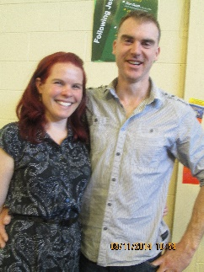

Thanks to the generosity of two of our volunteers, Nigel and Rachel Tilley, three families have been able this year to access free assistance with car repairs and servicing. This couple keep aside funds to support this service and Nigel has provided his own skills as a mechanic free of charge

Thanks again to Nigel, we have been able to purchase and put on the road another loan car to replace one we lost midyear due to a collision with a kangaroo! These loan cars have been an invaluable support to many who would struggle to keep their job without a car to get them to work. One car is currently providing a single mother with a chronic illness the means to get her children to school and herself to medical treatment until she can afford to fix her own car.

**5 DENTAL HELP**

For a number of years now Dr Lester Mark has provided free dental work to some of our most needy people in his “PAY IT FORWARD” scheme, encouraging those who receive this gift to be willing to help others with the talents they have. His assistance this year has included a full root canal on one client and the filling of many teeth for very grateful clients who can experience relief from painful toothache and long waits at the community dentist

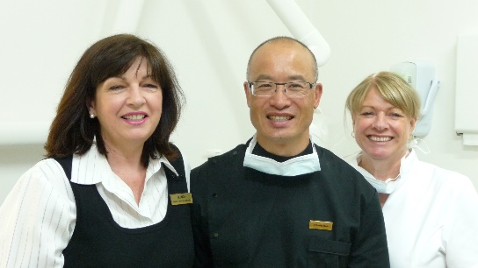

!

**6 FURNITURE AND HOUSEHOLD GOODS**

Thanks to the generous donations of many people, we have been able to help many families with good quality household goods and furniture, including beds, tables, cots, whitegoods etc Many more have been supplied with free good quality clothing and goods from the Op Shop. We have also provided many newly arrived refugees with blankets, with many donated by St Matthews. Some very faithful and talented knitters, including Marg Ashworth, Noble Park CWA, YOGO and Endeavour Hills Neighbourhood Centre have supplied us with beautiful baby and toddler jumpers, teddies, scarves and blankets

**7 CHILD SPONSORSHIPS**

Over the past 12 months the Centre has sponsored young people from disadvantaged families with the means to pursue their area of particular talent, including this year a young boy who is playing in Perth with the State Rugby team, another talented hockey player and a team of under 16 boys forming a basketball team and needing to hire somewhere to train.

**COUNSELLING** $49,766.00

The Andrews Centre has a seemingly endless stream of people coming for counselling with one or other of our counselling team. The comprehensive range of counselling and relevant related services provided at the Andrews Centre continues to be of vital importance to many families and individuals in the Casey area and beyond. It is rewarding to note just what a difference it can make for many people rendered unable to cope with everyday life by grief, depression, trauma or relationship issues. For an increasing number of people this counselling is literally life-saving!

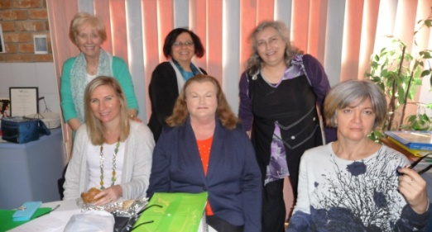

The Andrews Centre boasts a most committed and caring team of counsellors and psychologists who work hard to support many in our community struggling with a whole range of issues affecting their ability to function well emotionally, socially or relationally. There continues to be a steady stream of referrals from doctors, paediatricians, pastors, schools and welfare agencies. This year we have had the services of two very qualified counsellors and six psychologists who all have particular specialties so that a whole range of issues can be addressed.

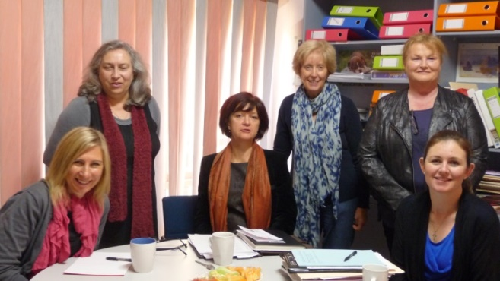

Over the past twelve months there have been over 4,000 individual appointments for counselling at the Andrews Centre as well as two group sessions run over two terms. Medicare has covered the cost of many but when the sessions permitted under Medicare are finished and clients still need help, the Centre has made sure those in financial hardship receive ongoing counselling at no cost or at a much reduced rate – depending on the individual circumstances. Over $24,000.00 was spent directly covering counselling fees on behalf of needy clients either in full or partially subsidized sessions. (and the necessary assessment materials). Counsellors do not have access to Medicare payments, so the Centre subsidises all clients on a healthcare card who need the particular expertise our counselling team provides. Additional costs associated with providing the counselling services include administration (photocopy, printing, stationery etc), rental, rates, utilities, insurance and resources We most sincerely thank the Andrews Foundation and City of Casey for their financial help to keep this very important service going We also thank the volunteers who give of their time and expertise to do administration and reception each day to support the counselling team.

1 **ADULT COUNSELLING**

Adult counselling is provided by two counsellors and two psychologists. Adult counselling encompasses a whole range of issues such as those summarized below

**A. Personal Issues**

* Depression – managing emotions, thinking rationally, reasonably and truthfully (cognitive behavioural therapy)
* Stress/anxiety
* Grief over the loss of a significant family member means they need support to deal with the loss and be able to trust loving someone else when losing a loved one feels so bad - also grief related to procreation eg. infertility, IVF issues, stillbirth or miscarriage
* Addiction Issues
* Self Esteem – racial vilification and self worth support
* Bullying issues and assertiveness counselling
* Trauma related issues – including undoing the effects of childhood abuse
* Pain Management and chronic illness support
* Parenting Support with Disabled Children
* Anger

**B Relationship Issues**

* Domestic violence and abuse issues
* Control and domination issues. This can include dealing with spousal or other relationships in which the other person is very difficult and sometimes severely personality disordered
* Divorce recovery – including supporting persons who have experienced marital rejection
* Providing a space for clients’ own value based responses to marital unfaithfulness
* Relationship problems
* Cognitive therapy (thinking rationally, reasonably and truthfully) towards greater personal and relational resilience
* Counselling for the aged with their relevant specific issues

**C. Mental Illness**

* Helping keep mental illness at bay. Management and therapy for clients with personality disorders

**2 THE VALUE OF AN INTEGRATED APPROACH**

Because the counselling service is part of the wider work of the Andrews Centre, we are often able to go beyond the immediate needs of emergency help to the more long term support provided by counselling that enables a person to recover emotionally and relationally so that they can survive and thrive into the future. There has been three occasions this year where clients were given counselling, legal advice, emergency help and emergency housing. Feedback from one of these clients speaks for itself of the value of having this integrated approach. The following is an excerpt from her letter

*Due to a mounting series of personal and family problems I found myself homeless and living in my car…..I was offered a unit to live in as well as a series of counselling sessions with a psychologist from the Andrews Centre. That was the first day of my journey towards healing and regaining control of my life…..I attended fortnightly counselling sessions which helped me unravel a lifetime of emotional and psychological damage. My psychologist turned out to be extremely lovely, kind, caring and empathetic to my problems and life story. Each session allowed me to slowly pick apart the events of my life, allowing me to see things in a much clearer light, along with tools to help me to deal with the various effects emotional abuse has had on my life and psyche. I will be forever grateful for those tools. The unit was for me a safe haven that allowed me the time to sort out the mess in my head and then to move on to sorting out the more practical aspects of life such as paid employment and a new place to live. Today I am happy and healthy. I have paid employment and have been able to find myself a new home………None of this could have been achieved without the help of the Andrews Centre*

3 a) **CHILD AND ADOLESCENT COUNSELLING**

Three of the psychologists work primarily with children and a fourth works almost solely with adolescents. The kind of issues they deal with include assessing children with potential behavioural or learning problems, helping children coping with issues related to autism ADHD or other syndromes, counselling children affected by trauma, parental separation, grief, bullying, low self-esteem, eating disorders, anxiety, depression – even suicidality.

b) **KEYS TO CONNECT**

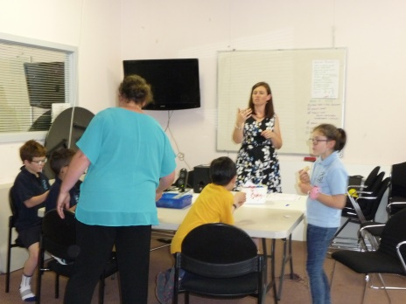

This year also included two group sessions These have been very successful groups run third and fourth terms this year with very positive feedback from the parents. The course aims to help children understand their own and others’ emotions and needs. Topics covered included ‘Communication’, ‘Body Language’, ‘Conversation Skills’ ‘Friendly Behaviour’ and ‘Problems Solving Skills’.

**c) ASSESSMENTS**

These psychologists work with children who present with a range of developmental disorders such as autism, ADHD and Aspergers Syndrome. They continue to do assessment work to ensure learning disabilities are identified early and funding is gained for children who will need extra help with schooling. Assessment reports are not covered under Medicare so the Centre has committed some of their funds to ensuring underprivileged children receive the help they need to obtain via these assessments. This year the team has been greatly enhanced by the addition of Karen Shirt who is an educational psychologist specializing in assessment work.

4 FREE LEGAL COUNSEL

Mr Noel Martin LLB(Hons) B Juris. Continues to provide many disadvantaged people with valuable legal advice, which is often an important additional support alleviating stress for people struggling with high anxiety as a result of circumstances such as family breakdown or domestic violence. Advice also includes help for the disadvantaged facing bankruptcy, eviction from housing estate issues, fines or issues related to traffic accidents

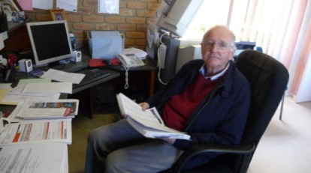

**5 SUPPORT GROUPS**

**AL ANON**

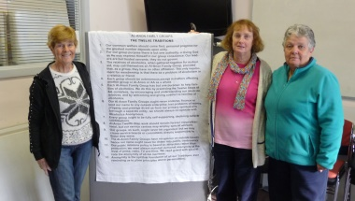

For the past 16 years this group has met each week providing support to families of alcoholics. It is always well attended and is a great support for many struggling families

**6 TEAM SUPPORT**

The team of counsellors and psychologists hold monthly meetings for mentoring and Personal Development. There is a real sense of partnership and Rosemary mentors members of the team individually. Rosemary also meets with a group of psychologists from a wider area who come together once every two months at the Centre.

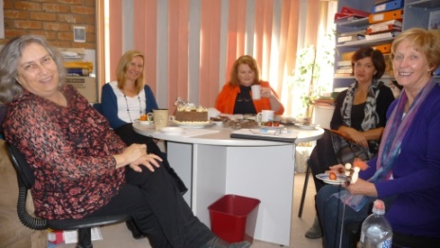 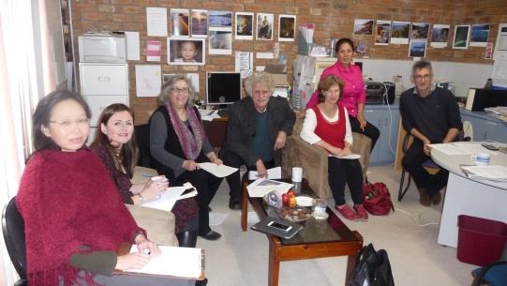

Meeting together with other psychologists from the Melbourne area

Monthly meeting of psychologists and counsellors

**EDUCATIONAL SUPPORT**

Gayle Houghton helped to complement the work of the psychologists, tutoring every week students the Centre has paid to receive one on one assistance with learning difficulties.

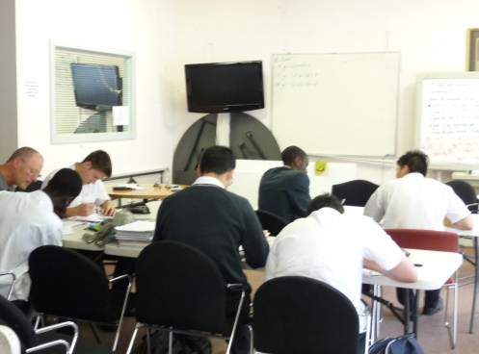

VCE Maths Methods: Every Monday a group of economically disadvantaged students receive free tuition from Mr Rob Daniels, retired Caulfield Grammar Head of Mathematics and Assistant Chief Examiner for VCE Specialist Maths.

.

**MIGRANT ENGLISH**

In 2016 help was provided to a Spanish and a Chinese student with one on one lessons helping them improve their written and spoken English

**COMMUNITY DEVELOPMENT**

1 OUTINGS & SPECIAL EVENTS

In March this year we took a busload of families to Gumbuya Park where they enjoyed lots of fun on rides as well time together enjoying a BBQ lunch and games

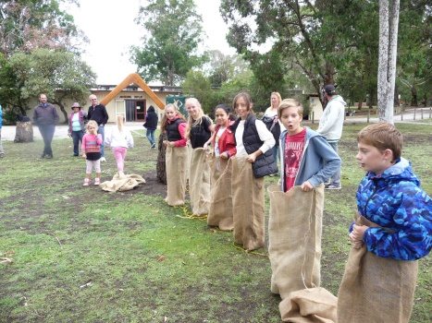 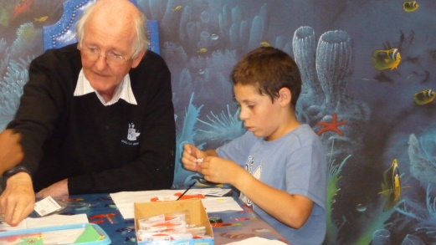

The children (and adults!) always love the gumboot throw competition and the sack races! (left)

Fun with Christmas craft at Xanadu December 2016

During the September holidays and again at the end of the school year families have enjoyed a night at the Xanadu Play Centre in Hallam where the children enjoy lots of play equipment and craft activities. The parents relax over a cup of coffee and some finger food. The night is capped off by a delicious pizza dinner ! Thank you James and Alison Ayling who have made this facility available to us at no cost beyond the food supplied.

In August this year families were given free tickets to Preston Rotary Club’s Circus Quirkus and in November they were also given the opportunity to take their family to the Lions Club Magic Show at the Melbourne Convention Centre. There was really positive feedback from families who thoroughly enjoyed both events

2 .**MEALS**

Every Monday between 40 and 90 people come for the Monday meals in Dandenong and every Thursday evening a smaller group meet together at Endeavour Hills. These meals also ensure a number of single men and women who are not looking after their own nutrition particularly well, are getting a nutritious meal. The Thursday meal featured a Christmas in July as well as an end of year Christmas party. The Monday Meals also had a big breakup with 92 sharing a beautiful Christmas roast and later all receiving a hamper!

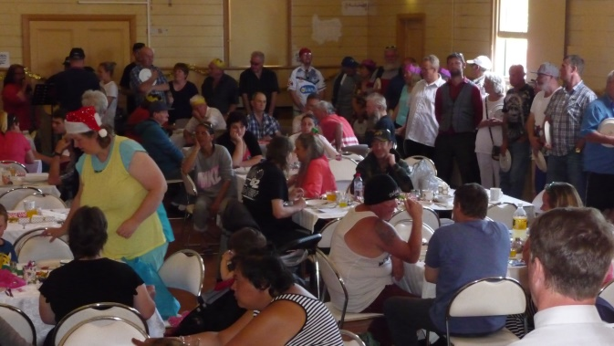 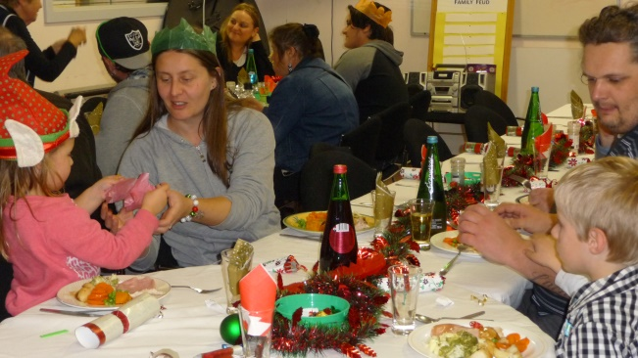

*Monday Meals crowd Christmas in July at the Thursday meal*

**3 COMMUNITY GARDEN**

Over the past 12 months we have seen the garden grow some very impressive crops of vegetables but it has proved so much more than just a place to grow food. We have had guest speakers bringing us together and teaching about grafting fruit varieties onto root stocks, composting, and growing organic vegetables. Thanks to Rotary we have an enclosed pergola under which to retreat and have a coffee after hard work in the garden!! The garden also boasts four prolific egg laying chooks!

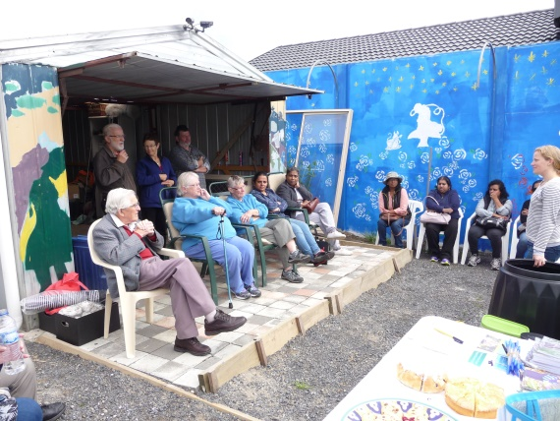

***Jodie Clarke talks about “Composting”***

Sadly our community garden manager is moving house and will be greatly missed by us all. Thank you to John Majkut for all he has done to promote and upkeep the garden. The garden boasts a large BBQ and pizza oven and has been a popular site for adults and school children alike as a place to “meet and eat!”

**4 QUILTING GROUP**

In the front room the patchwork quilting club “Sew Loved” continues to meet once a month. This very special group of ladies has made a number of beautiful quilts for needy individuals known to them at the Centre. They are a very supportive community together

**5 KIDS CLUB**

The Centre makes their facilities available to a Fijian Indian group whose children meet together each Saturday to enjoy each other’s company and learn together.

**OPPORTUNITIES TO VOLUNTEER**

Apart from the psychologists and counsellors all members of Endeavour Ministries Inc are voluntary and there is a wonderful sense of “team” about all that happens as part of Endeavour Ministries Inc. Many of our volunteers have been with us since we started back in 1994! We have also been blessed this year with the help of different groups from Maranatha Christian School who have done a lot of garden maintenance at the Centre, the emergency house and the community garden. The Year 8 students at Beaconhills College spent one Saturday painting a beautiful mural across the back fence at the garden. It looks fabulous! Students from Berwick Fields Primary, Southern Cross Primary and Gleneagles Secondary as well as our littlest helpers at Rose Garden and Goodstart Childcare Centres have also collected food to support the work of the Centre.

**RAISING FUNDS TO SUPPORT THE WORK**

**POLICE GOLF DAY**

Once again this year the local Police and Friends have organised a Charity Golf Day where the majority of the profits go to the work of the Andrews Centre. Their support is a real encouragement to us and is really appreciated. Every year they raise over $7,000 for the Centre

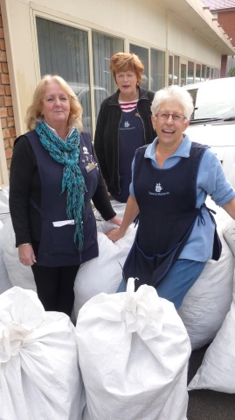

**ENDEAVOUR OPPORTUNITY SHOP**

Our team of volunteers running the shop do an amazing job, sorting, cleaning, pricing and selling goods, the profits of which all go to support the work of the Andrews Centre . This year they raised around $60,000 (after expenses) as well as providing free clothing and furniture items to many needy families. Every year they sort through and organise thousands of tons of goods and the managers in particular devote many hundreds of hours every year keeping on top of the many generous donations by members of our community. Thank you Liz and Jenny for your wonderful leadership and commitment as Managers of the Op Shop team.

**CHRISTMAS HELP**

Christmas is a wonderful time of the year where we rejoice of the generosity of so many in our community wanting to do their part to make Christmas a special time for all – especially those in need. We received once again some beautiful hampers from both St Paul Apostle and also a group of young mums called “The Sisterhood” We received gifts and food from St Matthews and St James Anglican churches, Endeavour Hills Uniting Church, Southern Cross Primary School, Glen Eagles Secondary School, Chalcot Lodge Primary School, Goodstart Learning and Rose Garden Childcare Centres and Endeavour Hills Neighbourhood Centre. Thank you once again to Jane Davis for the provision of Christmas cakes for our hampers

**SUPPORT FROM FOUNDATIONS & TRUSTS**

We acknowledge with great appreciation the key role that the Andrews Foundation has played in making possible the very existence of the Andrews Centre. The Foundation has partnered with us in the work of the Andrews Centre, covering rental costs and also helping us with the counselling services provided at the Centre. We also acknowledge and truly appreciate the support provided the E C White Trust, helping us support many at risk of homelessness. We acknowledge with gratitude the help of the Helen Macpherson Trust who provided specific funding for us to support many disadvantaged families with the means to purchase the laptops required by the local secondary school for all Year 7 and Year 10 students.

GOVERNMENT AND OTHER SUPPORT

Thank you to the Federal Government for help funding food vouchers for emergency relief service. Thank you to City of Casey for help both with our emergency relief and counselling programs (as well as $800 towards the cost of fixing up the new accommodation) and City of Greater Dandenong for help with the Monday Meals program. We also appreciate financial support provided by Specsavers and Grid Light and Power . Thank you to St James and St Matthews Anglican Churches, Endeavour Hills Uniting Church and Narre Hills Community Church, Maranatha School for help with food.

**INDIVIDUAL SUPPORT**

Finally, but very significantly, the Centre acknowledges with gratitude the individuals who have provided ongoing financial support and the many who have dedicated their time and talents as part of the Endeavour Ministries team to help make possible all that has been achieved in 2016! Well done to you all!.



All donations over $2 made to Endeavour Ministries Inc are tax deductible