ANDREWS CENTRE

Ship4

## **ENDEAVOUR MINISTRIES**

2-6 Hanna Drive, Endeavour Hills, 3802

Telephone 03 9700 4944

Fax 03 9700 0822

ABN 70 891 996 288

**QUARTERLY REPORT**

APRIL – JUNE 2017

Another three months have flown by and thanks to the generosity of many providing financial and material help and/or time and talents, we have been able to help many families and individuals in real need of our support.

Thanks to a continual stream of donations from a very supportive community Endeavour Opportunity Shop continues to provide very affordable good quality clothing and household goods to families whilst also raising valuable funds to be used in our counselling and emergency relief programs .

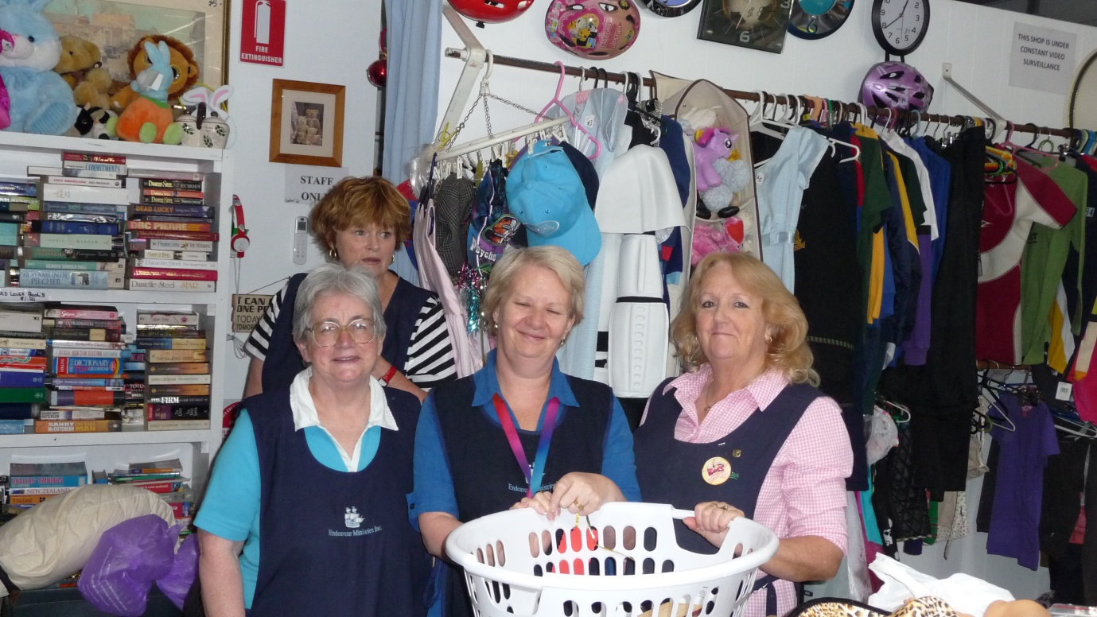

We are sad to say goodbye to Brenda Hall who has been a faithful member of the Op Shop team since around the time we started in 1994. She had a role as a Manager for a number of years. She will be sadly missed as will her team of faithful helpers who have also retired – Dorothy Crawford, Hinke Valk and Renice Thompson.

**RESPONSIBLE RESCUE FOR FAMILIES IN HOUSING CRISIS**

For a number of years now, we have sought to address this problem which seems to be growing ever more serious and more overwhelming as time goes on! Recently I was invited to attend a meeting at the City of Casey with others helping the homeless and those at risk of homelessness in the Casey region. All of us recognised homelessness as a somewhat hidden but very real problem in our area. Many individuals and families are either “couch hopping” or living in their cars. Our emergency accommodation is in high demand as so many families struggle to pay rent or find affordable private rental after leases expire or after family breakdown forces them to move house. It is particularly difficult for single or small families because there is a real shortage of one or two bedroom units (In the City of Casey 95% of housing is three or four bedroom and only 1% is one bedroom accommodation). Many unemployed reliant on newstart allowance struggle to even afford boarding house accommodation and many caravan parks will no longer take on people on newstart allowance.

“Responsible Rescue” is about providing help to families in housing crisis to achieve private rental, survive unforeseen crises affecting their ability to pay existing rent and more effectively manage rental payments into the future. Thanks to a grant from the Lucinda White Foundation for the next financial year, we will continue to provide this most necessary service.

“*Mary” and her sixteen year old son have been sleeping in her car for the past month. He is doing his VCAL at a local secondary college and she is sick with emphesema. They actually spent the night in the front room at the Andrews Centre before WAYSS was able to find more permanent accommodation for them*

*“John and Jenny” have come to Australia from New Zealand. They have six children and really struggle to find permanent jobs which will secure their ability to pay rent. They rely on casual work which is not always available and this has meant they have had to seek help with rent arrears on different occasions. Fortunately they have both found permanent work in country Victoria. We were happy to help them with rent in advance to move to what will be a much more secure housing situation.*

*“Harry” is a single dad with four children He only has casual work and he fell behind in rent when he tried to pay for his very talented son to go interstate to play sport for an Australian team. The Centre paid the arrears to get him back on track*

**EMERGENCY HOUSING**

More permanent accommodation has now been found for our mother of four (with a fifth on the way!) and our single mother with one child (both domestic violence situations). Their units have been taken up by two more mothers, both with two children. One is a new mother of twin babies who was homeless!! The other two units continue to house a refugee mother of three and a very ill mother with an autistic son

**A NEW LOAN CAR**



After our faithful Toyota Camri finally died, we decided to replace it with a Toyota Corolla. The other loan car is currently being used by a refugee in our emergency accommodation who has three children and who needs a car to begin to seek for work

The Andrews Centre provides families in need with loan cars for a period of five months to help them to save money for their own car and make sure they have the means to get to important appointment or work commitments

**OTHER HELP FOR FAMILIES IN CRISIS**

BLANKETS AND WARM CLOTHING

There has been a number of requests for warm blankets and clothing – especially from individuals moving into boarding houses often with no bedding. We have also handed out swags to some homeless individuals when unable to provide motel stays or emergency accommodation. Thanks to donations from one kind individual we provided beds and a washing machine for one refugee single mother with four children moving from the emergency accommodation to a more permanent home.

FINANCIAL ASSISTANCE

Many needy families have been provided with assistance with chemist, utility, upfront specialist fees, medical equipment (wheelchair, walker, vapourizers and new glasses), petrol, car registration and car repairs and educational expenses such as camps and computers (compulsory for all year 7’s). Thanks to Dr Mark we were also able to provide dental help for people who were in immediate need and unable to afford dental treatment. The Centre also paid to make it possible for a young girl to participate in a local netball team.

THE MATTRESS APPEAL

Those of you who have noted our advancement into the 21st century will have seen our new Facebook page!! We made an appeal through Facebook to raise funds for “John” who was injured at work and needs a special bed to give him any hope of being able to sleep at night. Such is the pain for this man, despite many operations to try to rectify the problem, that he actually collapsed and further damaged his shoulder. His collapse was attributed to sleep deprivation! The insurance company agreed to cover the cost of the bed base but not the mattress – little comfort for a man who can barely afford his weekly rent and food!! Anyway thanks to some generous supporters we will now be able to purchase a mattress and this man is grateful beyond words for the help given!

**MONDAY AND THURSDAY MEALS**

The Monday Meals team is now catering for a minimum of 70 people each week and it is often a lot more!! They do a wonderful job catering for so many and even giving “little extras” for the participants eg bananas and muesli bars etc to take home. The Thursday meals continue to cater for a mix of families and individuals who enjoy coming together to enjoy each other’s company and enjoy some delicious delicacies such as chocolate cheesecake, roast chicken, lasagne, apple pie etc etc

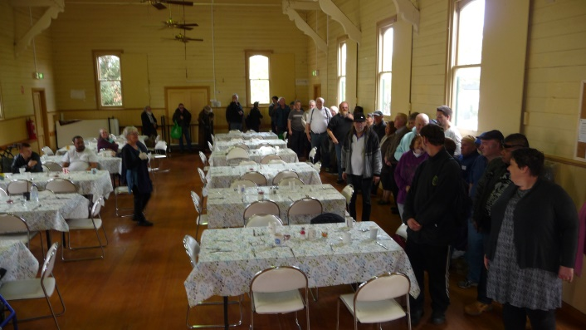 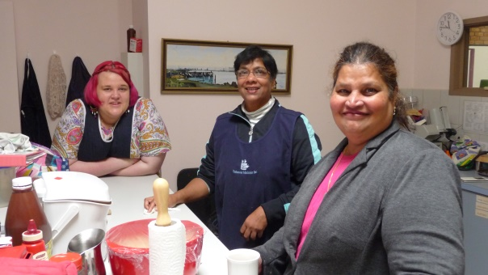

*Lining up for lunch at the Monday Meal Preparing the Thursday Meal*

**COMMUNITY GARDEN**.

Winter crops are now in and all the garden beds have been claimed by enthusiastic gardeners. The chooks have ensured a steady supply of eggs which have been used in the meals and for distribution to families in need. Some of the vegetables have also supplied the Monday and Friday meals and the scraps from the meals go back into the garden compost or to the chooks!!



Students from Maranatha help with garden maintenance , including feeding our compost!!

Dad and daughter plant vegetables in their new garden bed

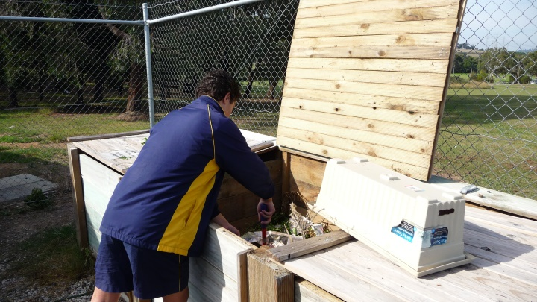

**COUNSELLING**

It is always a challenge to meet the demand for counselling at the Andrews Centre, despite the fact that we have 7 psychologists and 3 counsellors on board!! The waiting lists never seem to shorten!! There are so many families and individuals struggling with everything from depression and anxiety, addiction issues, family breakdown, trauma, anxiety and clinical issues such as eating disorders, schizophrenia, bipolar disorder As well as bulk billing clients to make sure everyone who needs counselling can afford it, the Centre continues to provide financial support to ensure people can afford counselling services and the assessments they might need. The counselling team continue to meet once a month together and to support and encourage one another and share knowledge and insights in the very important work that they do. A wider network of psychologists from outside also meet once every two months at the Centre.

In line with our intent to be a very integrated service, Endeavour Ministries can often afford a needy family a number of integrated services – emergency relief to meet immediate financial or material needs, but also referral internally to counselling or free legal services. We have also paid for families to spend a weekend of respite where needed to locations such as Benwerren in the Yarra Valley,where we know they will be looked after and supported

**EDUCATION**

Migrant English classes are provided for individuals at the Andrews Centre Judy is currently teaching a Spanish speaking physical education teacher English by insisting she start each lesson with exercise instruction – strictly in English!! Gayle continues to provide tutoring to help students with learning difficulties.

**HAPPY BIRTHDAY QUILTERS!**

Our quilting group recently celebrated their 5th birthday together. On the right is an example of some of their beautiful work, many of which they give away to needy families

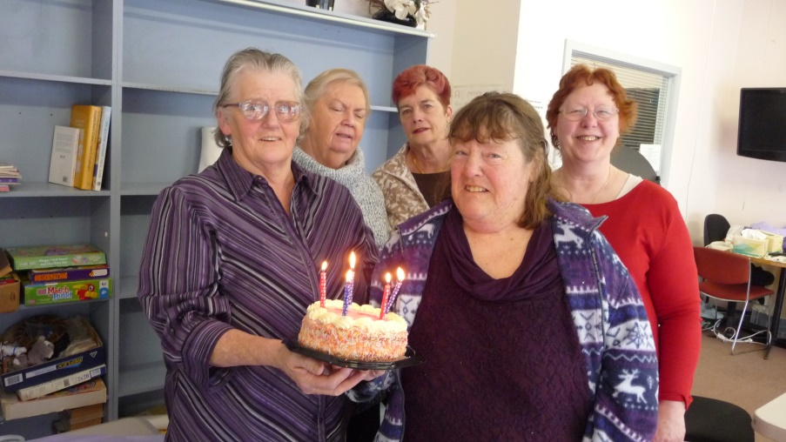 

The front room continues to be used to support other groups who do valuable work into the community including Endeavour Hills Lions and Lionesses (Tuesday nights) and the Al Anon group who meet every Monday morning.

Once again, and with no less enthusiasm or sincerity, I continue to thank the many people who by dedication of time, money, material donations and prayer make this ministry possible.

Judy Martin

Endeavour Ministries acknowledges with sincere gratitude our financial support and partnership with The Andrews Foundation and the valuable support of DSS, , Endeavour Hills Rotary, EC White Trust, Lord Mayor’s Charitable Trust, The Lucinda White Trust, Endeavour Hills Lionnesses, City of Casey, St Matthews and St James Anglican Churches, Endeavour Hills Uniting and Catholic churches