ANDREWS CENTRE

Ship4

## **ENDEAVOUR MINISTRIES**

2-6 Hanna Drive, Endeavour Hills, 3802

Telephone 03 9700 4944

Fax 03 9700 0822

ABN 70 891 996 288

**QUARTERLY REPORT**

JANUARY – MARCH 2017

*Whoever is kind to the needy honours God – Proverbs 14v30*

The first three months of this year have been incredibly busy and quite challenging with an average of 100 appointments each month just for emergency relief clients. This does not include the many many clients coming each day for counselling or legal help appointments, tutoring, meals, classes or even help with advocacy or filling in forms.

*CRISIS HELP SERVICES*

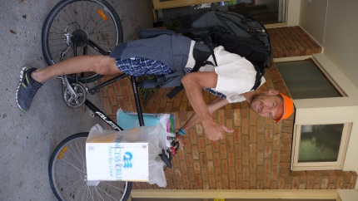

Families in crisis have many and diverse needs. Apart from food vouchers and food, there is often a need to respond to urgent needs for medication, upfront specialist fees, help with petrol, car repairs or registration costs so that people can get to work or hospital appointments etc. There is often a need to help families with rental arrears. Many just need someone just to listen to them as they can feel very much alone and overwhelmed by their circumstances.

*Amazing how much*

*Food you can fit on a bike!*

MATERIAL SUPPORT

Materials provided have included loan cars, clothing, crockery, small furniture items, beds and even swags for the homeless.

*A worker from WAYSS in Dandenong approached Judy with the need for a bed for a 46 year old lady terminally ill with advanced lung disease COPD brought on by domestic violence. Her illness has meant her 10 year old son is now living with foster parents and though she had been granted a unit through public housing, she did not even have a bed to sleep in! Consequently 2 days after she was discharged from hospital she ended up back there because she had slept on the floor!*

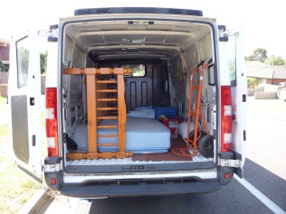

*The Centre managed to procure a good bed and some bedding for this lady faithfully delivered by our “truckie come lawyer” Noel!*

HOUSING

Mr Tony Nicholson Executive Director of the Brotherhood of St Lawrence pointed out in a recent article that “less than 0.5% of the rental market in Victoria was affordable for those living on unemployment benefits, with pensioners only marginally better off. Equally struggling are those on bridging visas and those who rely on very unreliable casual work because it is the only work they can get! It is little wonder that we are constantly trying to help people who are in rental arrears facing imminent homelessness, or indeed, those who are already homeless sleeping rough or sleeping in their cars.

*“June” is a single mother who struggles to pay $400 a week in rent. She has two dependant teenagers (both studying). She received $980 per fortnight and struggles to make ends meet. Like many others in her situation, the most mundane unforeseen expense results in rent arrears and the threat of eviction. In her case – the exhaust pipe fell off her car as she travelled home from visiting her sick mother. She was forced to get the car towed and she had to get a taxi home. She had no way of covering the subsequent $420 rent debt and was facing imminent eviction. The Centre was able to cover this expense*.

We have also helped five families with emergency accommodation over the past three months. All five families were victims of domestic violence and the accommodation has provided a safe haven for them and their children and a chance to receive helps such as counselling, meals and even an outing with the Andrews Centre. Housing Support Workers have helped and are helping these families in the search for more permanent affordable accommodation.

Every Tuesday we have a Housing Support Worker from WAYSS present at the Centre to help people in housing stress. We work closely with WAYSS and Windermere as we seek to help these very vulnerable and traumatised women and children.

LOANS

No interest loans are provided to many for items such as whitegoods, as well as for car repairs, educational needs and even rent arrears. We currently have 37 loans on the go. The loans provide a really valuable service to people and help them to keep clear of unscrupulous money lenders seeking to exploit their desperate need for quick money. All loans are repaid directly through Centrelink and it is relatively rare that loans are not repaid in full.

EDUCATION

A large number of families have really struggled with the costs associated with getting children back to school equipped with all the uniform, books and technology required!! For students at our local secondary college it has been particularly challenging, as every Year 7 and Year 10 students is required to purchase a computer costing at least $1000.00. The Andrews Centre has contributed $7,000.00 in direct donations and $15,500.00 in no interest loans to help families meet this particular cost. A further $2000 was dedicated to helping families with uniform and books.

“*Mary” is a single mother with four children living in a caravan whilst she desperately searches for somewhere she can afford with her four children One of the children has a kidney disease where she is often hospitalized with kidney stones The Centre made a donation towards the cost of the computer needed and subsequently supported her with food vouchers.*

*“John”, his wife and four children are currently living in one room in their parents’ home ,losing their home after falling behind in rent. They have moved into the Endeavour Hills area with three teenagers – all needing computers! The Centre has providing a donation and no interest loan repayable at a rate to enable this family to cope with this expense!*

Migrant English classes are provided for individuals at the Andrews Centre and Gayle continues to provide tutoring to help students with learning difficulties. Rob Daniels is offering VCE Maths Methods classes for students on a Monday night at the Centre.

 

**SPONSORSHIPS**

It is always close to our heart to support those who have achieved despite their disadvantaged circumstances.

This year the Andrews Centre has provided sponsorship to two young men, one from a single parent family and one has been raised by his pensioner grandparents. The first is an Australian champion ballroom dancer and the other is in the under 16 Australian rugby team.

MONDAY AND THURSDAY MEALS

Ron and Roslyn continue to do a great job supported by a dedicated team of workers every Monday at St James church hall in Dandenong. At the end of year dinner there were 92 guests who all received a beautiful Christmas hamper and a free photo sitting! Every week this year there is at least 60 people waiting to enjoy the culinary delights on offer. Every Thursday a group of around 20 to 30 people share a meal at the Andrews Centre in a very relaxed setting where we share food and “food for thought”.

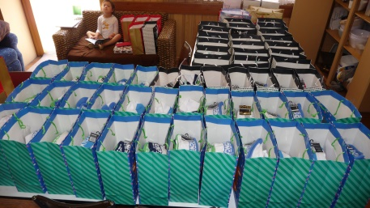 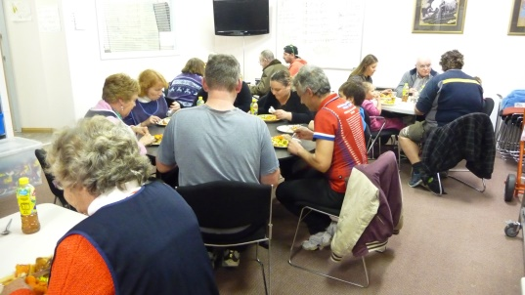

*91 Christmas hampers lined up at the Monday Meal Thursday meal at the Centre*

OUTING TO MORNINGTON PENINSULA

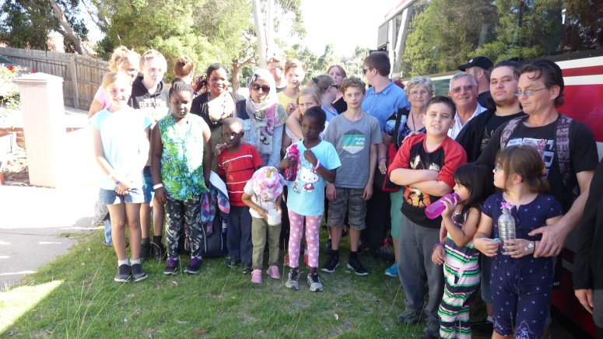 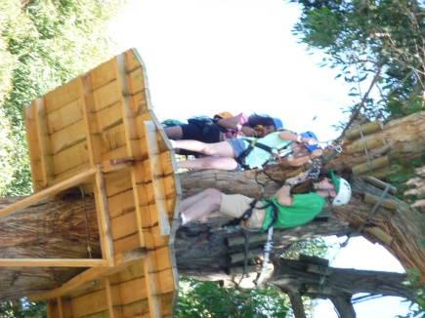 

In early March a large bus arrived at the Andrews Centre ready to transport 41 guest eagerly awaiting their special outing to the Enchanted Adventure Park at Arthurs Seat on the Mornington Peninsula. The families were all people who rarely get to go anywhere because of severe financial hardship. One family who is quite new to Australia had never been anywhere before apart from the suburb in which they live. The teenagers went tree surfing and some of the younger children (and some of the braver adults) went on a very challenging flying fox ride across a lake!! Everyone had a great day!

**COMMUNITY GARDEN**

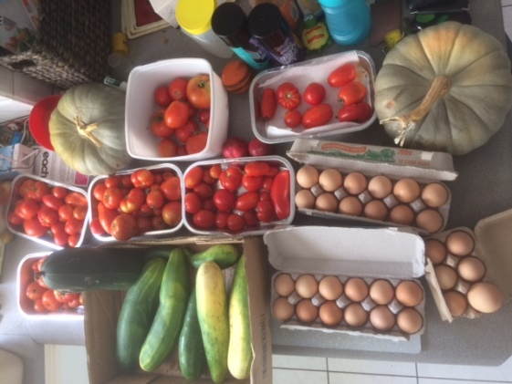

There has been an amazing crop of summer vegetables from our community garden! Tomatoes, cucumbers, pumpkins, corn, cantelopes, beans, lettuce – the list goes on!! Those attending the two meals have been the lucky recipients of some of these fresh vegetables. Almost all the beds have now been taken up and autumn planting is now happening.

Geoff Brooke gave a talk to our gardeners in February on everything to do with fruit trees, which was followed by a BBQ and was enjoyed by all. Thanks to Endeavour Hills Rotary we now have the pergola filled in to make a really nice meeting room and place to go to relax indoors on the garden site. It is appropriately entitled “Diggers’ Den”.

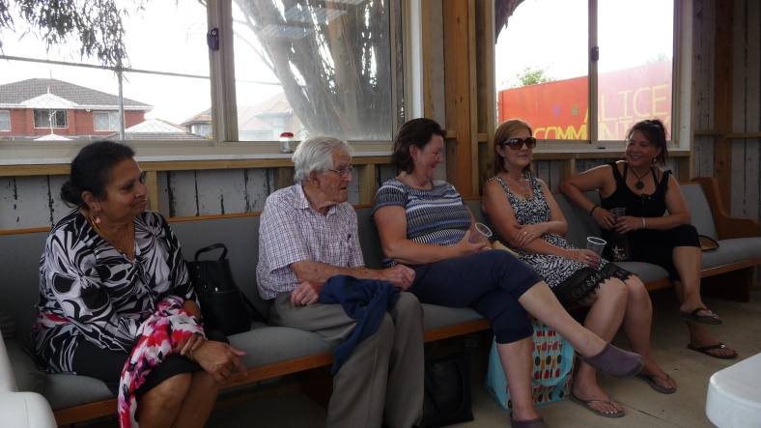

*Relaxing in “Diggers’ Den listening to Geoff tell us all he knows about growing fruit trees.*

**COUNSELLING**

There are many families and individuals struggling with everything from depression and anxiety, addiction issues, family breakdown, trauma, anxiety and clinical issues such as eating disorders, schizophrenia, bipolar disorder The Andrews Centre has a committed team of 7 psychologists and 3 counsellors and their services are an important accompaniment to our crisis care, helping many to deal with issues which can significantly affect their ability to cope and recover from challenging situations. As well as bulk billing clients to make sure everyone who needs counselling can afford it, the Centre continues to provide financial support to ensure people can afford counselling services. Support has also been provided for disadvantaged children needing assessments for suspected intellectual disabilities or autism etc

This year we welcome a new psychologist Nathan “on board”. Nathan(M.Psych MAPS AHPRA) has experience working across a broad spectrum of ages and clinical diagnoses including severe depression, eating disorders, alcohol and drug addictions and shizophrenia. He has also facilitated group recovery programs eg Life Matters and Drug and Alcohol Recovery.

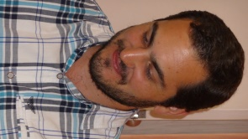

OP SHOP



The Op shop has been incredibly busy since the doors opened mid January. The number of donations has been quite amazing and ensure that we are able to provide a wonderful array of items to sell. Jenny, Jo and Liz have done an exceptional job keeping on top of all the sorting and we are so grateful for the great job they do.

*A mountain of donated items fill the whole middle aisle of the shop!!!*

The proceeds from the shop are a valuable source of funding for all that happens at the Centre and we also call upon them to provide clothing and household goods for some of our most needy clients. We are sad to say goodbye to Peter Spry who, along with Noel, does the “shop pick up “ every week transporting bags from shop to Centre for collection. We have really valued his quiet and faithful service.

We continue to be so grateful to the many people who support our work into the community with everything from donations of money, Op Shop goods and many many volunteer hours at the shop, Centre and the meals. We also very much value the many who pray for the work that is done every day to support many vulnerable and needy people in our community

Judy Martin

Endeavour Ministries acknowledges with sincere gratitude our financial support and partnership with The Andrews Foundation and the valuable support of DSS, , Endeavour Hills Rotary, EC White Trust, Lord Mayor’s Charitable Trust, Endeavour Hills Lionnesses, City of Casey, St Matthews and St James Anglican Churches, Endeavour Hills Uniting and Catholic churches