ANDREWS CENTRE

Ship4

## **ENDEAVOUR MINISTRIES**

2-6 Hanna Drive, Endeavour Hills, 3802

Telephone 03 9700 4944

Fax 03 9700 0822

ABN 70 891 996 288

**QUARTERLY REPORT**

JULY TO SEPTEMBER 2017

We hear so much in the news about the amazing rise in the value of housing in so many areas of Victoria. The unfortunate accompaniment to this is the rising cost of rentals for the many families unable to ever even look like affording their own home! The main housing agency in this area reports that single people on the newstart allowance cannot even afford most boarding houses now, since they are charging over $200 per week for a single room! Many of the caravan parks will not allow people on newstart to even apply to rent a van! The Andrews Centre provides temporary accommodation in four units for periods between three and six months to give families time to save towards private housing . Whilst in the houses they are also provided with support from WAYSS to achieve private rental and free counselling for adults and children at the Centre, where there has been eg domestic violence. Sometimes they might also need to access our free legal advice service.

*“Sophie” is a mother of three children who was evicted from her private rental after her partner left because she could not afford to pay the $420 per week on her own. She was also the victim of domestic violence. “Karima” is a refugee fleeing domestic violence and political persecution in her own country. She has a very limited income from Red Cross and would be in real trouble affording any accommodation for herself and her three children. The emergency accommodation has meant a great deal to her and she has also benefited from English lessons at the Andrews Centre to help her with pronunciation skills to better position her for potential employment.*

*“Gina” came into the Andrews Centre very distraught. She poured out her whole story to me starting with her breakup with her partner who owned the home they were living in. She sought alternate accommodation through flatmates.com and managed to find what seemed a reasonable lodging in the Cranbourne area, in share accommodation. Unfortunately, three days after she arrived she was assaulted by the fellow tenant and was at once forced to seek immediate alternate accommodation. She sought help from a government housing agency who could only suggest she seek accommodation in a boarding house in Endeavour Hills where there was a spare room available. The room turned out to be windowless and she was surrounded by many tenants fresh out of jail, or with drug, alcohol or mental health issues! She was horrified and was even advised by the boarding house manager not to stay there. She ended up at our Centre. We provided her with two nights’ accommodation at a local motel because we had no room at our emergency houses and were able to contact WAYSS to find her other options.*

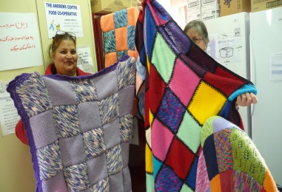

The Andrews Centre tries to be proactive with ”at risk” clients helping with rent arrears so that they don’t end up homeless. Where individuals and families are already homeless, various helps and referrals are provided. Sometimes the most we can offer is a swag and blankets so at least they are warm and dry!!

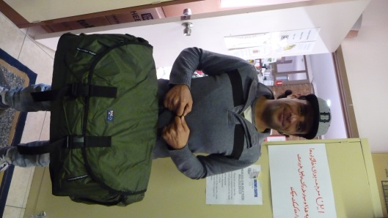

SO GOOD TO HAVE THE SHOP!

There are times when people come to us seeking help even with clothing. A young teenage boy left his home in a hurry due to family violence and went to live with his sister. He only had the clothes he left home with, so we were able to help him both with vouchers to purchase clothing and with good quality jeans and jumpers from the shop.

*“John”, in his early 30’s, is autistic and very shy. He lived with his mother in our emergency accommodation after the landlord sold their private rental and forced them to move. The mother was very ill and eventually died, leaving her son struggling to manage on his own. His brother who lived in Adelaide agreed to look after the funeral arrangements for the mother but John did not even have anything appropriate to wear to his mother’s funeral. Thanks to a good supply of men’s clothing, we were able to “fit John out” for the funeral with suit, shirt, tie and shoes. He looked rather handsome!! After the funeral John received help to sort through paperwork and consider alternate accommodation options. John is now living with his friend in the city*

Thank you to the many who continue to donate to the shop, as it is a great source of funding for the Andrews Centre as well as supplying clothing and household goods for those in need

“ADRIAN’S” BED

“Adrian” is a man in his late forties who worked full time until an accident caused him to badly injure his back. He has had a number of operations but is still in such pain that he actually collapsed from lack of sleep, further injuring himself in the fall!! His specialist recommended he should have an electric bed to help him sleep and the insurance company eventually agreed to pay – but only for the base! Brian had no means of paying the $2000+ to cover the cost of the mattress. He was on workcover and then on newstart payments which barely covered the cost of his rent and food!

Thanks to the generosity of some of our supporters, we have been able to purchase an electric bed for Adrian and he is absolutely delighted!

**EMERGENCY HOUSING**

The units continue to be in high demand, with so many struggling to cope with high rentals or rendered homeless as a result of family breakdown and/or domestic violence. In the past three months we have provided housing for four families caught up in domestic violence situations. We have also provided housing for a refugee family of four unable to find any private rental. .

**LOAN CARS**

We now have two cars “on the move” – one being used by our refugee family and the other has been used by two different single mothers temporarily without a car due to the breakdown of their own vehicle.

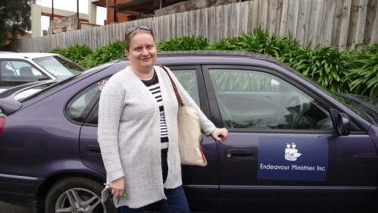

**OTHER HELP FOR FAMILIES IN CRISIS**

MEDICAL HELPS

There are a number of ways we have been called upon to assist families struggling with sickness and injury. Apart from a number of chemist bills we have helped with the upfront specialist fees for those who would struggle to afford this extra cost. The Centre has also provided some donated medical aids such as vapourizers and nebulizers, shower chairs, wheel chairs, walkers, and a lifter for people with back problems to aid them getting out of bed! Thank you to those who donated! The dentist continues to assist us by seeing some of our most needy patients with dental problems.

OTHER FINANCIAL ASSISTANCE

Many families have struggled this winter with the high cost of utility bills, so funding has been allocated to help many families with this expense. For many families we have advocated to achieve bill reductions and utility relief grants to lessen the considerable financial pressure they are experiencing. Help has also been provided for car registration, car repairs, school expenses and work wear to enable people to get back into employment.

FOOD

The cupboards empty and the cupboards refill on a regular basis!!! So much food is given away every day that it is a real blessing to have the help of so many who faithfully supply extra food every week to help us restock!! Noel travels down to Dandenong each fortnight to collect food from Foodbank This has been supplemented by donations from Endeavour Hills Uniting Church, St Matthews Church, Maranatha School and Narre Hills Community Church. Thank you to you all who have provided this valuable support!

MONEY MINDERS

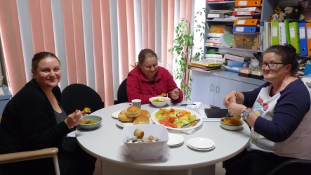

One of our new volunteers has been running a very practical course for anyone interested in learning how to best manage on a very limited income. It includes budgeting skills and tips on saving money etc

EMERGENCY RELIEF TAKES ON A NEW MEANING!!

A Monash Medical Centre caseworker sent her disabled client our direction to see if we could help her with a rather awkward problem in her home. Her toilet had fallen through the floor in her rather run down home. She was reduced to using a bucket!! Thanks to the kindness of our builder and those he co-opted to help, we were able to replace the floor boards and the toilet for $300! We made this a donation to the poor lady!

FREE LEGAL HELP

This has been such an important help to many who feel so disempowered by not understanding what they can do when confronted with legal problems they are not sure how to address, This can be anything from custody and financial issues related to family breakdown, to traffic accidents or fines, to tenancy issues. Noel’s advice and support to many of the people we see is absolutely invaluable.

**MONDAY AND THURSDAY MEALS**

The Monday Meals team has made a total of 622 meals in the months of July and August at a total cost of $2085! Meals have included such favourites as “roast chicken, chicken stir fry, roast beef, fish and chips, shepherd’s pie, and roast lamb”. The team arrives very early to peel potatoes and other vegetables. Of course, the meals are always followed by a tasty dessert! The Thursday meals continue to cater for a mix of families and individuals who enjoy coming together to enjoy each other’s company and a good feed! Thank you to all those who do such a wonderful job cooking up some beautiful meals!

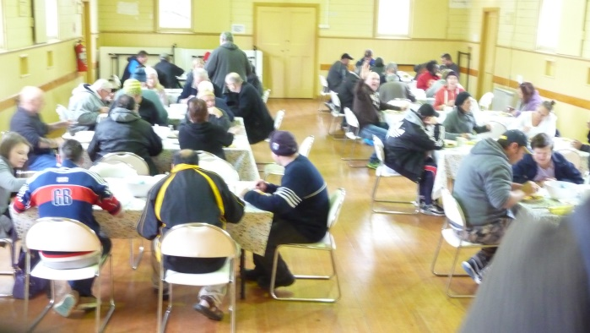 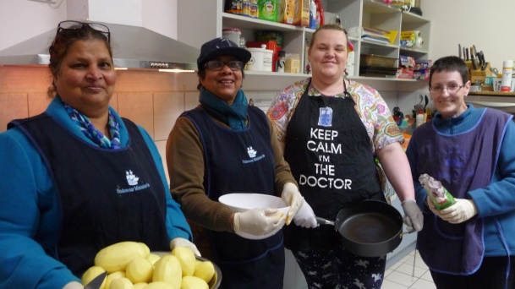

*Enjoying the Monday Meal Preparing the Thursday Meal*

**COMMUNITY GARDEN**.

We have now harvested our winter crops including some big cauliflowers, potatoes, carrots and beans. We are all looking forward to some Spring sunshine to plant our new crops. Thanks to a grant from the Casey Cardinia Foundation, we will also be able to have an on site toilet – a very welcome and necessary addition!

**COUNSELLING**

*‘Mary” is a student at a secondary college where she has been really struggling to cope. She was highly anxious and had reached the point where she hated going to school. She had received funding in her early primary years for a learning disability but subsequent testing put her just above the level where funding was provided. By the time she came to see one of the counsellors, she was really struggling and very miserable. This psychologist was able to provide her with support both with counselling and with a new assessment which showed her to be at a level where she was eligible for funding to receive help at school. (The Andrews Centre helped pay for this assessment due to the financial disadvantage of the family) The psychologist also liaised with the school to help them understand how best to help this young student. The difference all this made was absolutely wonderful. The young girl came back to share with her psychologist the pride she felt in being able to do things at school she had never been able to do before – including telling the time and division.*

It would be an understatement to say that the counselling service has been very busy. There are waiting lists for all our psychologists despite the fact that we have seven of them and three other counsellors on board. There are many families and individuals struggling with everything from depression and anxiety, addiction issues, family breakdown, trauma, anxiety ,eating disorders, schizophrenia, bipolar disorder etc As well as bulk billing clients to make sure everyone who needs counselling can afford it, the Centre continues to provide financial support to ensure people can afford counselling services and the assessments they might need. The counselling team continue to meet once a month together and to support and encourage one another and share knowledge and insights in the very important work that they do. A wider network of psychologists from outside also meet once every two months at the Centre.

**EDUCATION**

Migrant English classes are provided for individuals at the Andrews Centre Judy currently has three students (two Spanish and one Ethiopian)

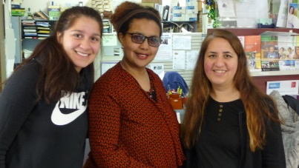

**OTHER COMMUNITY ACTIVITIES**

The front room continues to be used to support other groups who do valuable work into the community including Endeavour Hills Lions and Lionesses (Tuesday nights) and the Al Anon group who meet every Monday morning. The quilting group continues to gather each first Saturday and these lovely ladies often donate their beautiful quilts to families in need!

Once again – it remains for me to thank the many faithful people who by dedication of time, money, material donations and prayer make this ministry possible.

Judy Martin-

Endeavour Ministries acknowledges with sincere gratitude our financial support and partnership with The Andrews Foundation and the valuable support of DSS, , Endeavour Hills Rotary, EC White Trust, Lord Mayor’s Charitable Trust, The Lucinda White Trust, Endeavour Hills Lionnesses, City of Casey, St Matthews and St James Anglican Churches, Narre Hills Community Church, Romanian Baptist, Endeavour Hills Uniting and Catholic churches

Manager