ANDREWS CENTRE

Ship4

## **ENDEAVOUR MINISTRIES**

2-6 Hanna Drive, Endeavour Hills, 3802

Telephone 03 9700 4944

Fax 03 9700 0822

ABN 70 891 996 288

**QUARTERLY REPORT**

APRIL – JUNE 2019

Second term is nearly over already!! It has been another busy three months with many families and individuals in desperate need of help. I am so grateful for all who support our work and make possible the many forms of help we are able to give.

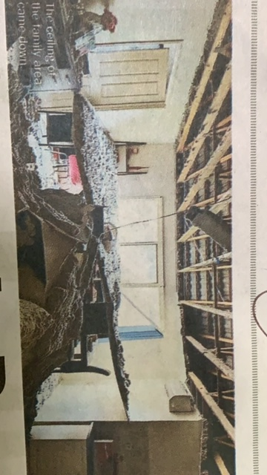

*“John and Mary’ and their two children were renting a property in Berwick when without warning the roof caved in, leaving the main living area of the house and all its furniture destroyed.*

*The family were forced to evacuate immediately and spend the night at their neighbour’s house. “Mary” was 34 weeks pregnant. The family came to see us because they had nowhere to go after this first night and no family in Australia they could turn to. We were able to put them up for a night in a motel. WAYSS provided another night but I was unaware that, though they had secured housing, it would take them a further week before they could move in. I was shocked to find out they had spent a night in their car because they did not know what else to do and did not think they could ask again for help! When I found out their predicament we offered to house them in one of our emergency housing units until they could move into new accommodation. They were extremely grateful as they never wanted to experience sleeping in their car again!!*

HOUSING

Unfortunately we are seeing many people who are either homeless or facing imminent eviction. Many have been helped with rent arrears and others who are already homeless have been given motel accommodation or time in our short term accommodation units. Over the past three months we have donated $9,510 (to end of May)in rent arrears and housed five different families including:- a refugee mother with her two daughters, two single mothers each with two children (both with domestic violence issues), a single father with two children and one single mother with four children who struggled to find alternate accommodation after the landlord sold up her rental accommodation . One of these residents wrote a long letter expressing all the ways the Centre had helped her including:

* Food and food vouchers
* Advocating for utility relief grants
* Emergency accommodation
* Donation of a computer for her daughter’s schooling
* Counselling for Post Natal Depression and Post Traumatic Stress
* Christmas Party for her and her children
* Christmas hampers
* Outings
* Thursday Meals

Her letter concluded with the following:-

*I really benefit from using the Andrews Centre. They have helped my family enormously and I’m forever grateful. Words can’t express how important the Centre is … We would all be so very lost without the Centre and so upset. It’s a very important place for my family as it would be for the community. They do so much to help us all and they definitely have and still do play a big role in my life. …..Amazing organization, amazing volunteers, I really can’t praise the Centre enough.*

GOD’S REMARKABLE PROVISION!

*“John” came in to the Centre wet, shivering with cold and very miserable. He was struggling to overcome an alcohol addiction and was doing well in Queensland staying with his grandparents and receiving treatment. Unfortunately he was required to return to Court in Victoria and had to find accommodation down here at a local boarding house infested with cockroaches where many other residents have addiction issues. He went downhill fast and ended up at Dandenong Psychiatric Unit for a period of time. Meanwhile the landlord assumed he was not returning to his room and threw out his clothes and bedding. John asked for help with clothing and I searched our Op Shop supplies but could not find much for him. Fortunately someone else we have helped out on different occasions came in at that very moment with a bag of men’s clothing, all of which fitted him perfectly!!*

*“Jenny” had been a former resident in our emergency accommodation. She had found alternate accommodation in a bungalow at the back of someone’s home but that house and bungalow were demolished and the only accommodation she could find was in a very isolated caravan park. She texted me in quite a desperate state, severely depressed, sick and very lonely. On the very same day another lonely and financially struggling single lady came in seeking help and someone to share her two bedroom unit. We were able to bring these two ladies together and they are now happily sharing a unit in Endeavour Hills!*

Every month we are seeing around 100 families for crisis help as people struggle to pay everyday expenses such as basic grocery, chemist, utility and travel bills. We acknowledge with gratitude the many who have helped us with food and other donations for families in need over the last quarter. This includes donations of food and linen from Endeavour Uniting Church, food donations from Rose Garden Childcare and Langwarrin Muslim group, toiletries from Year 7 Maranatha, computers from Narre Hills Community Church, knitted goods from Endeavour Hills Neighbourhood House and blankets from Kogo.

NO INTEREST LOANS

One of our valued volunteers, Bill Matthews, has been kept busy organizing no interest loans for items such as whitegoods, school computers, car repairs and registration. This is such a valuable service to keep our most financially vulnerable families out of the hands of unscrupulous payday lenders! Bill also spends time with clients who want help with budgeting so that they can successfully manage with very limited income.

LOAN CAR

At present our loan car is transporting a single mother with four children around to her many medical appointments whilst her own car is being repaired



‘COOL MONEY’

Bill has been busy educating a group of young teenagers from Maranatha on how to manage money. The course he has run incorporates financial literacy training and the promotion of community awareness whereby young people are made aware of just how difficult it is for people to survive solely on Centrelink payments.

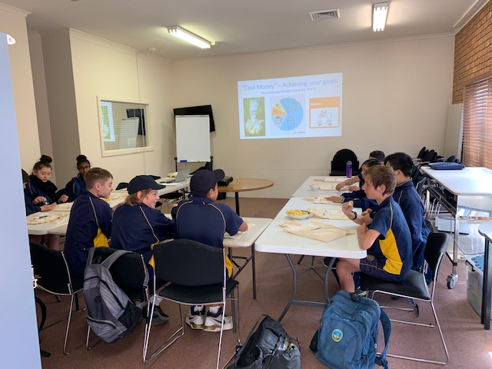

OP SHOP

Our faithful volunteers continue to do an amazing job sorting, pricing and selling donated goods to provide very affordable clothing and household goods for many, whilst also raising much needed funds for the Andrews Centre crisis support program. Thank you to the many volunteers who have done “over and above” these last months to cover others who have been away or sick.

MEALS

Every Monday a faithful team of volunteers arrive around 8am to prepare the lunch and also to serve people who begin arriving around 9am for morning tea The new freezer has been terrific and has allowed the team to store a donation of 30 dozen hot cross buns to serve the early arrivals with their hot drinks! Many of these are sleeping rough, so they make the most of the warmth, a friendly chat and the morning tea The lunch crowd (averaging around 60 people) are served a hot meal and dessert and are given fruit and sometimes other “goodies” to take home. .

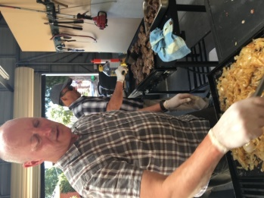

After lunch many of the guests make their way up to the back of the hall to participate in a special government program called “Reclink” engaging them in sporting activities such as soccer, footy, frisby throwing or bocce. This is a government program but the coordinators come down to the meal to chat with the guests and help out. It is great to welcome three new volunteers to the team, one retiree and two young people!

*One of our Thursday meals chefs noticed that “George” – a regular attendee – was wearing some pretty worn out and tattered clothes. She decided to donate a nice windcheater with a hood to help him survive the winter chills. He was really pleased and put it on straight away! He also scored a beautifully knitted single blanket donated to the Centre by Kogo.*

*We have tracked with “Kylie over the past two years as she travelled every weekend to Northern Victoria to help with the care of her three grandchildren. Her daughter was in a rehabilitation facility battling to overcome addiction issues and regain custody of her children. Apart from practical helps such as petrol and food vouchers, we have given Kylie a listening ear and have shared in her prayer to see her daughter overcome addiction and return to her children. Kylie has just spoken to me and is just so grateful to see her daughter back with her children and doing very well in her own private rental “drug free’ for the last twelve months*

COUNSELLING

All our psychologists and counsellors are extremely busy with long waiting lists. We only wish we could provide for all the sessions that are needed but are doing our best to help as many as possible with this most valued service. We continue to see people of all ages for everything from depression, anxiety, grief, trauma, relationship issues to children and adolescents dealing with bullying issues, family breakup, school related anxiety or needing assessments for learning or behavioural issues

It is with great sadness that we have to say goodbye to Jean Battersby who is retiring at the end of June. She is so faithful, wise and gentle with a good sense of humour! She is a wonderful and well respected counsellor and a valued long term member of our counselling team. We will all miss her greatly!



LEGAL HELP

It is always a great help to be able to “seek to wisdom” of our in-house lawyer! Often people presenting for crisis assistance have legal issues which they have no idea how to address, leaving them feeling disempowered and overwhelmed. It is so important for them to have someone able to direct them as to what they are able to do – be it a domestic violence or custody issue, or a tenancy problem, or even a car accident.

EDUCATION

Complementing our educational assessment work done by our psychologists, one on one tutoring is provided to help children with specific identified learning problems. Judy also does English as a second language classes every Monday at the Centre

CALL TO PRAYER

It is a challenging time for the Andrews Centre as we contemplate how we might continue this ministry into the future. We believe that God has called us to this work and we have seen His wonderful provision many times over the past 25 years. At the end of this year, however, we face a real challenge. The philanthropic funding which has paid the Lease for the past 19 years on the Andrews Centre ceases in April next year. We are not sure what the future holds in terms of our location and funding. We therefore felt it was right to call together the churches and friends of Endeavour Hills to pray with us for God to open the door for this ministry to continue. It was wonderful to see Christians from so many different churches answer this call and unite with us in prayer for the whole future of Endeavour Ministries Inc

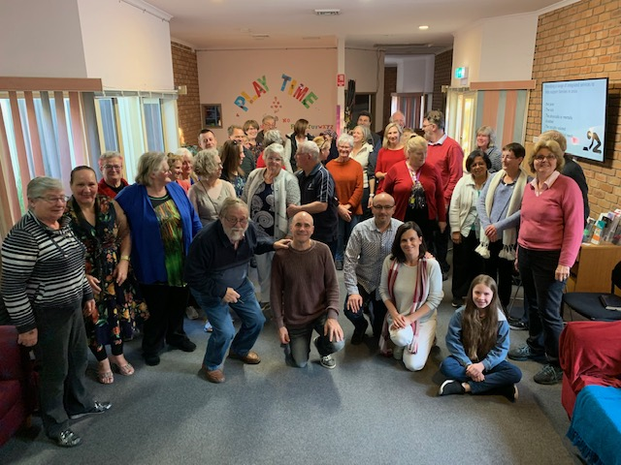

It remains for me to thank our many faithful supporters, including all our volunteers and all who support us with donations of food and other goods and those who continue to provide our much needed financial support.

*Judy Martin*

Endeavour Ministries acknowledges with sincere gratitude our financial support and partnership with The Andrews Foundation and the valuable support of Peter and Lyndy White Foundation, DSS, Endeavour Hills Rotary and City of Casey