Ship4

## **ENDEAVOUR MINISTRIES**

2-6 Hanna Drive, Endeavour Hills, 3802

Telephone 03 9700 4944

Fax 03 9700 0822

ABN 70 891 996 288

**QUARTERLY REPORT**

JULY TO SEPTEMBER 2022

*“John” lost his job when car trouble meant he could not get to work. Because he is from New Zealand, he is not eligible for Centrelink payments and so he also fell behind in rent payments. He was able to take out a no interest loan through the Centre to cover his car repairs and his registration and we also helped him by covering rent arrears to keep a roof over his head and work clothes to get him started at his new place of employment. He has now paid back his registration loan and is doing well.*

*“James” is homeless and currently sleeping in the car park at our local shopping centre. He is hoping for WAYSS to find accommodation for him soon and he has a job interview tomorrow for a forklift job. In the meanwhile he has come to the Centre for help and received a food parcel, food voucher, a shower, a hot meal and foam bedding base to replace the cardboard he has been using to sleep on! He left us the following message:-*

*To the team at the Andrews Centre. God bless you for your love and guidance and most importantly your understanding…I thank you from the bottom of my heart. You have given me love, support and companionship. Keep up the good work, your effort is outstanding. If only the world was as caring and loving as the Andrews Centre in Endeavour Hills.*

The Andrews Centre continues to see around 100-130 families per month for crisis help (130 in August). Currently the numbers are increasing due to high rental and utility costs and the significant rise in the cost of many foods. The help we give can range from simple food vouchers and food parcels to petrol and chemist vouchers, material donations of bedding, towels, clothing, financial donations towards rent arrears, up front specialist fees, school expenses, utility costs, removalist costs, car repairs and white goods. In the past three months we have spent over $10,500 just purchasing food, a further $19,000 in vouchers and around $11,000 in financial donations.

*“Nigel” was referred to the Andrews Centre by one of the local hospitals. He has been diagnosed with leukemia and bone cancer and has a wife and three small children. His wife had to give up her work to support him and get him to all his medical appointments. Meanwhile she has been visiting a laundromat with all her family’s clothes because she had no effective means to dry their clothes! The Centre was able to purchase and deliver a dryer to her to at least take this burden from her at this very difficult time for the family.*

*“Mary” had never sought help before but was really struggling due to a run of health issues including having to undergo three different operations with another one pending. It was great to be able to take some of the financial pressure off her and her husband by paying some of their utility expenses.*

*The Centre has also spent over $600 covering the cost of medications for one poor man who lost his job and has been subject to fitting following a significant head trauma. The only medication he can tolerate is costing him around half his jobseeker payment each fortnight which means that by the time he pays rent he literally has no money to feed himself! The Centre is also paying for his counselling.*

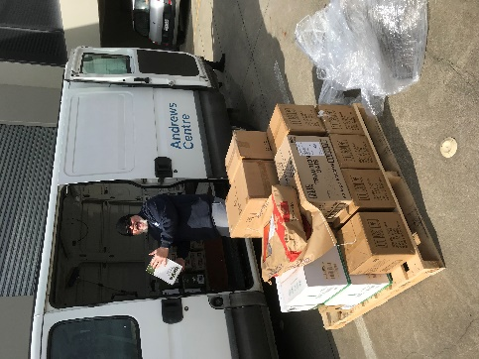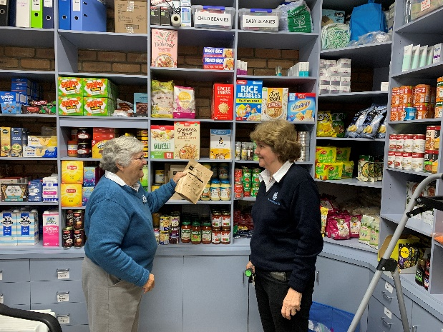

Part of the role of the crisis team is to provide those seeking help with referrals outside our organization which would be helpful to them in their circumstances. Over the past term Bill has been able to help some families with English as a second language, or who just struggle with computer skills, to be able to access the State Government $250 rebate on electricity bills.

Thank you to Endeavour Hills Uniting Church and Narre Hills Community Church for their donations of food as well as other generous individuals providing special supplies of clothing and other goods. Our special thanks to organizations such as the Neighborhood House supplying beautiful baby cot quilts and Kogo supplying knitted baby clothes and blankets for us to give away. Thank you, too, to Share The Dignity for a very much needed supply of sanitary items for people in need.

**LOAN CARS**

We also loan out two cars at no cost so that families are able to get to work or to medical appointments. Over the past three months the cars have helped two single mothers with significant health issues get to medical appointments and their children to school. One car has also been used to help a single father get to work after his own car was written off in a car accident.

**HOUSING**

Shortage of Housing remains a major problem in our area, as in many other areas. We are seeing a number of people sleeping rough in the open, or in their cars. Our four emergency housing units have provided shelter for four different families – all single mothers with children and all victims of domestic violence. Two of the four families have recently found more permanent accommodation and one has won a hard fought court battle to allow her to return home overseas. The Centre has also been able to support these families with crisis help whilst in the accommodation and even organized through YMCA for one of the children to access free gymnastic classes!

It is always a joy to meet people who have sought our help in years past who come up to tell us how well they are doing now. One such lady approached me at the shopping centre to remind me of her many visits many years ago when she was a single mother struggling after surviving domestic violence and continuous financial hardship. She told me she has been working now for a number of years and remarried. Her husband and her are doing well financially and even heading overseas on a holiday!

**NO INTEREST LOANS**

We have welcomed a new volunteer’ Ameet, onto our loans team. Ameet has a background in finance and he is a great compliment to all that Bill is doing to encourage people to access no interest loans where they are needed and where this helps them avoid having to access exploitative money lenders to purchase necessary items. Both also help people with budgeting advice.

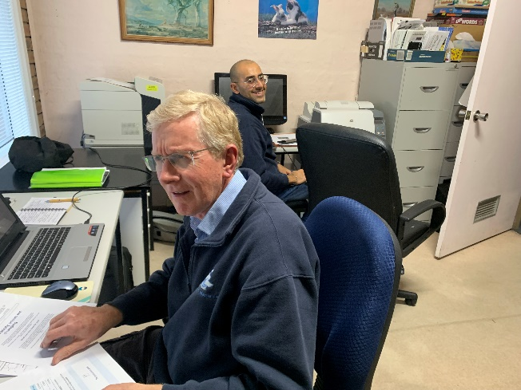

COOL MONEY – A TEENAGE LITERACY PROGRAM

Bill and Ameet have run three different Cool Money programs for around 60 to 65 students from Years 9 and 10 at Gleneagles College. The program aims to help students to understand how to go about doing a budget and also help them gain an appreciation of just how difficult it is for people to try to survive financially whilst relying solely on Centrelink payments.

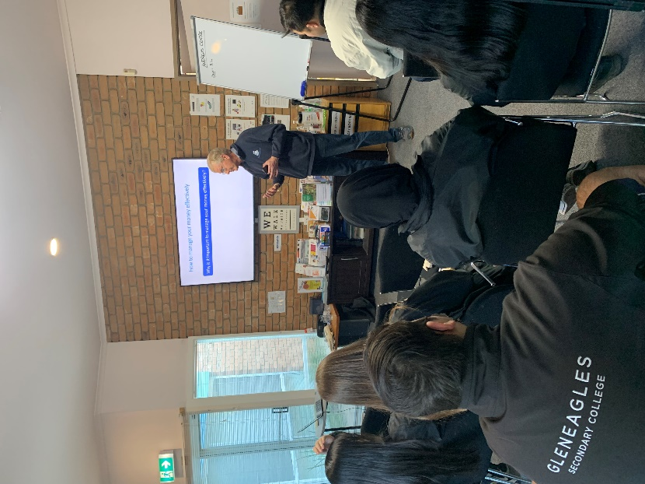

**MONDAY MEALS**

Every week a faithful team of hard working cooks is providing over 140 meals to people from the Dandenong, Doveton and Endeavour Hills areas. They sit down to a two course meal and get to take home fruit and other goodies after the meal. Before the meal guests have access to the mobile shower truck where all soaps, towels and shaving gear are provided. This is particularly helpful to some of the homeless who come each week. After the meal Reclink takes those guests interested in some exercise and recreation up to the multi purpose sports area for games.

MEALS FOR STORAGE

Sue comes every couple of weeks to the Andrews Centre and “cooks up a feast”. She makes up individual meals for around 50 to 60 people and these are frozen and stored at the Centre for the homeless and for those in boarding houses who often do not make many nutritious meals for themselves.

*“Mary” has been helped in the past and wanted to “give back” She has just made the most beautiful lasagna for us to slice up and distribute to those in need. – such a blessing!*

***Shirley slices up the lasagna Monday Meals desserts Sue preparing meals for freezer***

**COUNSELLING**

The psychologists and counsellors are all very busy and there are still long waiting lists for a number of our psychologists. Fortunately, we have recently been able to welcome a new provisional psychologist, Samuel Meyer, onto the team and have also welcomed an experienced and highly qualified Art Therapist, Anita, who will start next term offering both individual and group work sessions.

The Centre offers counselling and psychological services over a wide range of ages and issues – including anxiety issues ,(social anxiety- especially post Covid 19 lockdowns, general anxiety, school pressure, specific phobias, PTSD) suicidality and self harm, relationship issues including parenting help, supporting victims of abuse and/or domestic violence, those with stress, depression, grief issues including those struggling with chronic and even terminal illness, to those diagnosed with autism, bipolar disorders. They also provide support to individuals with low self-esteem, , victims of bullying, people seeking help with anger management or addiction problems. The Andrews Centre continues to subsidize or fully pays for a number of individuals to ensure that they are able to access psychology and counselling services.

PEERS

Over the past term two of our psychologists, Emma and Susan, and one of our counsellors, Coral, have run this program with two concurrent groups - one for teenagers with social skills issues and one for their parents. It has proved a very successful program, encouraging teenagers to learn how to make and keep friends and helping their parents to know how best to support their efforts. The effects of social isolation related to lack of social skills effects many teenagers profoundly – causing anything from depression, anxiety, school refusal, bullying to even suicidality. This program is therefore an invaluable tool to help these teens overcome the issues related to their inability to successfully connect with others.

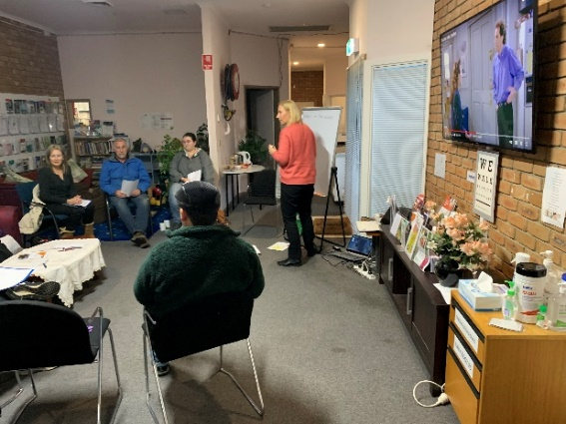

**OP SHOP**

What would we do without our faithful Op Shop volunteers. Many have been with us for over 20 years! Not only do they provide valuable funds to help with the running expenses of the Centre, but they provide our emergency relief team with clothing, and bedding for many we are trying to help. Liz has also made up crockery and cutlery packages for people moving into the local boarding house. We also have a store of medical aids to give to people who would struggle to afford to buy equipment such as wheel chairs, crutches, shower chairs, wheelie walkers etc

Liz, Andy, Lorraine and Peg do a wonderful job of sorting the many donations which come through the shop and we are also very thankful for the work Karin does to sell some items online!

**EARLY LITERACY PROGRAM**

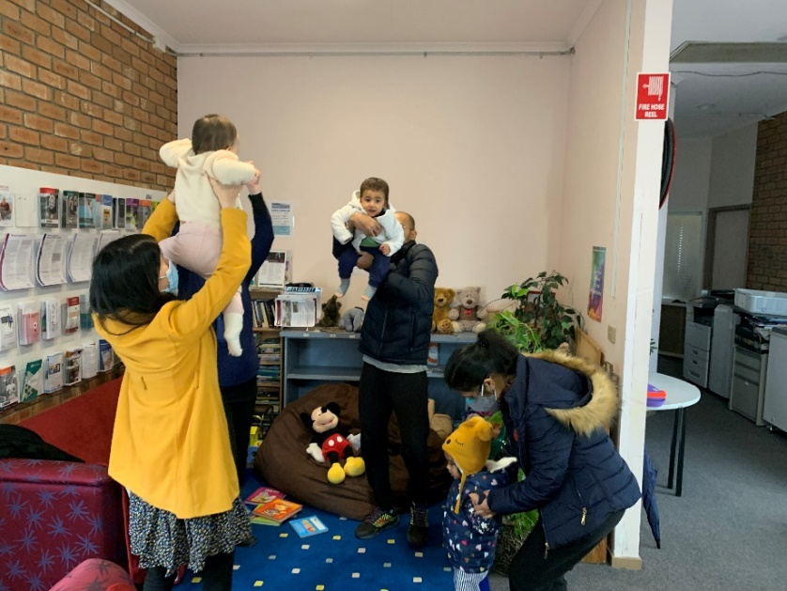

In partnership with the Endeavour Hills library we have been able to run an exciting early literacy program for children two years old and under. It has been very entertaining for all and a really valuable program to introduce little ones to literacy and the joy of books, words, actions and rhymes.

**MIGRANT ENGLISH**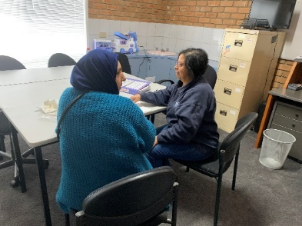

Heather, Shadia and Judy all work with individuals wanting to practice their English skills – one is Sri Lankan, one Cambodian and one from Iraq! Learning English can be a real challenge for these migrants – especially when their alphabet is totally to that of English speaking people.

**COMMUNITY GARDEN**

**

All the beds are currently being used and a variety of winter crops have recently been harvested – cauliflower, broccoli, snow peas, pumpkins, potatoes – as well as a good supply of eggs from the five resident chooks!

The trees have also supplied us with an abundant crop of lemons and oranges. Maranatha Christian School VCAL class looks after one bed to supply vegetables for the Monday meals and other vegetables have been provided to both the Monday and Thursday meals and/or to crisis relief. The garden team has met for morning tea and spent one morning mulching the area around the beds to allay the ever present threat of weeds! Another meeting is being held this week to begin our Spring planting**.**

**FAREWELL NOEL**

On Saturday 3 September the Management Committee officially said goodbye to Noel Martin and spent time to acknowledge all he has done to contribute to the work of Endeavour Ministries Inc. ever since it was started 28 years ago. He has provided free legal advice, served on the Committee of Management, done banking, furniture delivery, support for the Op Shop, involvement in the meals and outings, in property maintenance and also help at the community garden. We all wish him well in his retirement.

**Judy Martin**

Thank you to all the organizations and individuals without whose support we could not keep doing this very important work in our community.

The Andrews Foundation;Danks Trust;Peter and Lyndy White Foundation;City of Casey; DSS;Specsavers; Hire a Hubby; Roman Works; Endeavour Hills Uniting, Anglican, Catholic Churches Victory in Jesus, Narre Hills, St James Anglican Dandenong

To donate towards the work of Endeavour Ministries the bank details are as follows

Account Name Endeavour Ministries Inc

Please provide email and/or address or name so that a receipt can be sent.

BSB 063610

Accnt 10419490

ALL DONATIONS OVER $2 ARE TAX DEDUCTABLE